VOCM FOOD PANTRY NEWS
Holiday Food Distribution
For Those In Need
Wednesday, December 22, 2021
Begins at 4:30 p.m.
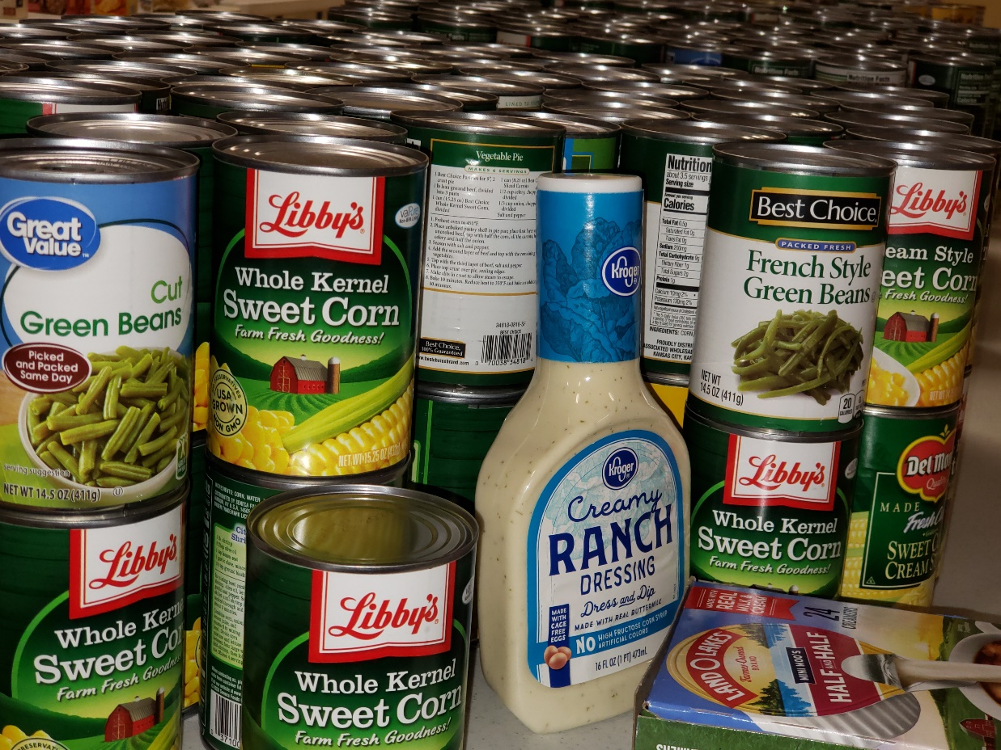

Since December 2017, Voice of Calvary Ministries (VOCM) FOOD PANTRY has served people in metro-Jackson who have experienced food insecurity with groceries and household items. This month, we thank Entergy for its generous gift that enables us to set up a larger space to better serve our families and individuals in need.

